http://www.unisbm.com/jh/iron.php
http://www.unisbm.com/jh/iron.php窗体底端
- Home
- Products
- Solutions
- Gallery
- Services
- About Us
- Contact Us
- Purchase
Home Iron

Iron Ore

Iron ore crushing plant, iron ore beneficiation and mining equipment video, pic, pdf used in india,china, Malaysia...

Iron Ore Material Introduction
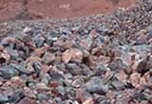
Iron Ore
Iron ores are rocks and minerals from which metallic iron can be economically extracted. The ores are usually rich in iron oxides and vary in color from dark grey, bright yellow, deep purple, to rusty red.

Iron ore mining equipment
According to the various sources of iron as well as certain economic and safety aspects in regards to its extraction is included, we provide you with a suitable iron ore mining equipment. The course we provide information of Iron ore processing includes comprehensive information on the beneficiation of iron ore including comminution, sintering, upgrading, and pelletizing aspects.
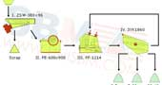
80tph - 120 tph
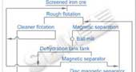
Project in Malaysia
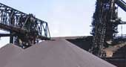
Iron ore mining process
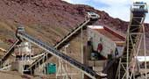
iron ore mobile crusher

Classification
iron ore can be divided into seven categories according to their causes: Maghemite, hematite, magnetite, limonite ,the siderite , pyrite, ilmenite

Distributed
The iron ore is distributed in Algeria,Egypt,Ghana,Kenya,Nigeria,South Africa,Sudan,Zambia,Zimbabwe,China,Russia,Australia,New Zealand,France,Germany,Iceland,Italy,Luxembourg,Netherlands,Norway,Spain,Sweden,Switzerland,Ukraine,United Kingdom,Canada,Cuba,Mexico,United States,Brazil,Chile,Peru,Venezuela,

Application
Iron ores are typically used for the production of iron. Then the iron produced is to make steel. Steel is used to make automobiles, locomotives, ships, beams used in buildings, furniture, paper clips, tools, reinforcing rods for concrete, bicycles, and thousands of other items. It is the most-used metal by both tonnage and purpose.

Iron Ore Processing

Iron ore crushing and screening machine
Mining and processing of iron ore involves coarse crushing and screening. Iron ore is beneficiated by crushing and then separating the iron from the gangue minerals through screening. This is usually so efficient that lower grade ore can be treated especially when the magnetite is quite coarse. Common iron ore crushers are jaw crusher, cone crusher and fine jaw crusher.
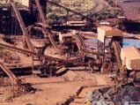
images of iron ore plant

Iron Ore Plant Line
Complete Stone Crushing Plant: http://www.unisbm.com/product/crushing/complete-crushing-plant/
Quarrying & Recycling Equipment: http://www.unisbm.com/solution/construction.php
Mining Equipment: http://www.unisbm.com/solution/mining.php
The crushing, screening, grinding, washing plant: http://www.unisbm.com/project/production-line.php
Project Cases: http://www.unisbm.com/project/

Iron Ore Processing Project Video
Video of bm iron ore processing plants used in india include iron ore crusher, grinding mill, beneficiation plants and other assistant equipments.
Iron ore processing plant works the initial physical treating part. Usually, sbm iron ore processing plants used in india include iron ore crusher, grinding mill, beneficiation plants and other assistant equipments.
High productivity and low maintenance are some of the traits that all of SBM’s processing solutions have in common – and that make the daily iron ore process a routine you’re pleased to depend on.
As the great majority of iron ore is used to make steel and iron, so the iron ore processing flow is usually of the same and fixed. SBM supply a complete line of iron ore processing production line.

Iron Ore Crusher Manufacturer
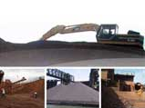
iron ore machinery pictures

Related Reading And Information Of Sand Download
iron ore crusher plant pdf
iron ore mining processing production line docx
Related Topics:
stone: http://www.unisbm.com/jh/stone.php
sand: http://www.unisbm.com/jh/sand.php
coal: http://www.unisbm.com/jh/coal.php
gold: http://www.unisbm.com/jh/gold.php
iron: http://www.unisbm.com/jh/iron.php

Top Need help? Live Chat
Page Navigation
Material Introduction
Classification
Distributed
Application
Iron Ore Processing
Iron Ore Plant Line
Iron Ore Processing Project
Iron Ore Crusher Manufacturer
Information
Technology Standard
Contact SBM
For product information and pricing, Chat with sales agent:

Page Tools
Live Chat
Email
Print Page
Add to My Favourite
Email: sbm@unisbm.com / Tel: 0086-21-58383022 / Purchase / Contact Us
News / Privacy / © 2010 UNISBM All Rights Reserved.

